**CINECONNECT: STREAMLINED MOVIE REGISTRATION AND REVENUE TRACKER**

**A PROJECT REPORT**

***Submitted by***

**MOHNISH M(220701171)**

***in partial fulfilment for the course***

**OAI1903 - INTRODUCTION TO ROBOTIC PROCESS AUTOMATION**

***for the degree of***

**BACHELOR OF ENGINEERING**

**in**

**COMPUTER SCIENCE AND ENGINEERING**

**RAJALAKSHMI ENGINEERING COLLEGE RAJALAKSHMI NAGAR THANDALAM CHENNAI – 602 105**

**NOVEMBER 2024**

**RAJALAKSHMI ENGINEERING COLLEGE**

**CHENNAI - 602105**

i

**BONAFIDE CERTIFICATE**

Certified that this project report **“CINECONNECT: STREAMLINED MOVIE**

**REGISTRATION AND REVENUE TRACKER”** is the bonafide work of

**“MOHNISH M (220701171)”** who carried out the project work for the subject

OAI1903-Introduction to Robotic Process

Automation under my supervision.

Mrs. G.M. Sasikala, M.E

**SUPERVISOR**

Assistant Professor

Department of

Computer Science and Engineering

Rajalakshmi Engineering College

Rajalakshmi Nagar

Thandalam

Chennai - 602105

Submitted to Project and Viva Voce Examination for the subject OAI1903-Introduction to Robotic Process Automation held on __________.

INTERNAL EXAMINER EXTERNAL EXAMINER

ii

**ABSTRACT**

CineConnect is an innovative RPA (Robotic Process Automation) solution designed to streamline movie registration and revenue tracking for the entertainment industry. Traditional methods of managing movie data and tracking financial performance often involve manual processes that are time-consuming, error-prone, and inefficient. CineConnect addresses these challenges by automating critical tasks, such as registering new movies, updating theater schedules, and generating real-time revenue reports.

The system leverages UiPath’s advanced automation capabilities to enhance operational efficiency and accuracy. By automating repetitive processes, CineConnect minimizes human errors, reduces processing time, and provides stakeholders with timely, data-driven insights. Key features include seamless integration with existing ERP systems, customizable dashboards, and automated compliance checks.

This project demonstrates how RPA can transform administrative functions in the entertainment sector, ensuring faster decision-making and improved resource allocation. CineConnect is scalable and adaptable, with potential future enhancements like AI-driven analytics for predictive revenue forecasting and customer trend analysis. Through automation, CineConnect not only optimizes workflows but also empowers organizations to focus on strategic growth and audience engagement.

iii

**ACKNOWLEDGEMENT**

Initially we thank the Almighty for being with us through every walk of our life and showering his blessings through the endeavour to put forth this report. Our sincere thanks to our Chairman **Thiru. S. Meganathan, B.E., F.I.E.,** our Vice Chairman **Mr. M. Abhay Shankar, B.E., M.S.,** and our respected Chairperson **Dr. (Mrs.) Thangam Meganathan, M.A., M.Phil., Ph.D.,** for providing us withthe requisite infrastructure and sincere endeavouring in educating us in their premier institution.

Our sincere thanks to **Dr. S.N.Murugesan, M.E., Ph.D.,** our beloved Principal for his kind support and facilities provided to complete our work in time. We express our sincere thanks to **Dr. P.Kumar, M.E., Ph.D.,** Professor and Head of the Department of Computer Science and Engineering for his guidance and encouragement throughout the project work. We convey our sincere and deepest gratitude to our internal guide, **Dr.N.Durai Murugan, M.E., Ph.D.,** Associate Professor, Department of Computer Science and Engineering, Rajalakshmi Engineering College for their valuable guidance throughout the course of the project. We are very glad to thank our Project Coordinator, **Mr.B.Bhuvaneswaran, M.E.,** Assistant Professor (SG), and Supervisor **Mrs. G.M. Sasikala, M.E., Ph.D** Department of Computer Science and Engineeringfor his useful tips during our review to build our project.

**Mohnish M(220701171)**

iv

**TABLE OF CONTENTS**

**CHAPTER NO.** **TITLE** **PAGE NO.**

|  |  |  |  |  |
| --- | --- | --- | --- | --- |
|  | **ABSTRACT** | |  | **iii** |
|  | **LIST OF FIGURES** | | | **vi** |
|  | **LIST OF ABBREVIATIONS** | | | **vi** |
| **1.** | **INTRODUCTION** | | | **1** |
|  | 1.1 | GENERAL | | 1 |
|  | 1.2 | OBJECTIVE | | 1 |
|  | 1.3 | EXISTING SYSTEM | | 2 |
|  | 1.4 | PROPOSED SYSTEM | | 2 |
| **2.** | **LITERATURE REVIEW** | | | **3** |
|  | 2.1 | GENERAL | | 3 |
| **3.** | **SYSTEM DESIGN** | | | **5** |
|  | 3.1 | GENERAL | | 5 |
|  |  | 3.1.1 | SYSTEM FLOW DIAGRAM | 6 |
|  |  | 3.1.2 | ARCHITECTURE DIAGRAM | 7 |
|  |  | 3.1.3 | SEQUENCE DIAGRAM | 8 |
| **4.** | **PROJECT DESCRIPTION** | | | **9** |
|  | 4.1 | METHODOLOGIE | | 9 |
|  |  | 4.1.1 | MODULES | 11 |
| **5.** | **CONCLUSION** | | | **14** |
|  | 5.1 | GENERAL | | 14 |
|  | **REFERENCES** | | | **17** |
|  | **APPENDICES** | | | 24 |

v

**LIST OF FIGURES**

|  |  |  |
| --- | --- | --- |
| **FIGURE NO** | **FIGURE NAME** | **PAGE NO** |
|  |  |  |
| 3.1 | SYSTEM FLOW DIAGRAM | 10 |
|  |  |  |
| 3.2 | ARCHITECTURE DIAGRAM | 12 |
|  |  |  |
| 3.3 | SEQUENCE DIAGRAM | 14 |
|  |  |  |

**LIST OF ABBREVIATIONS**

|  |  |
| --- | --- |
| **ABBREVIATION** | **DEFINITION** |
|  |  |
| API | Application Programming Interface |
|  |  |
| CRM | Customer Relationship Management |
|  |  |
| ERP | Enterprise Resource Planning |
|  |  |
| OCR | Optical Character Recognition |
|  |  |
| IDE | Integrated Development Environment |
|  |  |
| UML | Unified Modeling Language |
|  |  |
| UI | User Interface |
|  |  |
| LMS | Learning Management System |
|  |  |

vi

**CHAPTER 1**

**INTRODUCTION**

**1.1 General**

The entertainment industry, particularly the film sector, generates vast amounts of data related to movie registrations, box office revenues, and audience engagement. Managing this data efficiently is crucial for informed decision-making and enhancing operational transparency. However, traditional manual processes for data entry, report generation, and financial tracking are time-consuming and prone to errors. This leads to inefficiencies in workflow and delayed insights. To address these challenges, the project "CineConnect: Streamlined Movie Registration and Revenue Tracker" introduces an automated solution using Robotic Process Automation (RPA). The system leverages RPA to simplify repetitive tasks, such as data collection, report generation, and financial tracking, enhancing efficiency, accuracy, and productivity within the movie industry.

**1.2 Objective**

The primary objectives of this project are:

1. To automate the movie registration and revenue tracking process using RPA technology.
2. To reduce manual effort and time required for managing movie-related data.
3. To ensure data accuracy and consistency, minimizing human errors.
4. To provide real-time reporting and analytics for better decision-making.
5. To develop a scalable and adaptable solution that can be integrated into other domains requiring similar data automation.

1

**1.3 Existing System**

The current process in the movie industry for managing movie registrations, box office revenue tracking, and generating reports is largely manual. It involves collecting data from various sources, such as cinema chains and distributors, and manually entering this information into spreadsheets or reporting tools. This manual approach is time-consuming, labor-intensive, and prone to human errors, which can lead to inaccurate data and delayed reporting. Additionally, the existing system lacks real-time insights and automated alerts, making it difficult to respond quickly to revenue trends or anomalies. The dependence on manual processes limits scalability and reduces overall operational efficiency..

**1.4. Proposed System**

The proposed system, *CineConnect: Streamlined Movie Registration and Revenue Tracker*, leverages Robotic Process Automation (RPA) technology to automate the data entry, report generation, and revenue tracking processes. Using UiPath, the system will extract data from structured sources such as spreadsheets or APIs and automatically input it into a centralized database. Key features of the proposed system include real-time data synchronization, automated report generation, and customizable dashboards for visual analytics. The solution ensures high accuracy, reduces manual workload, and provides real-time insights into revenue performance. This automated system not only improves operational efficiency but also empowers stakeholders to make data-driven decisions quickly.

2

**CHAPTER 2**

**LITERATURE REVIEW**

**2.1 General**

Automating data management processes, such as movie registration and revenue tracking, is crucial for optimizing operations in the film industry. Traditional systems often rely on manual data entry, which is time-consuming and prone to human error. Such inefficiencies can lead to delays in decision-making and inaccuracies in revenue analysis. Robotic Process Automation (RPA) offers a reliable solution, automating repetitive tasks to improve accuracy, reduce errors by up to 90%, and significantly enhance productivity.

Tools like UiPath provide advanced automation capabilities, including data extraction from structured and semi-structured sources, seamless integration with web-based platforms, and real-time analytics generation. These features enable organizations to maintain up-to-date, accurate records while minimizing manual effort. Studies highlight that the adoption of RPA not only accelerates workflow but also allows companies to allocate human resources to more strategic roles.

In the context of the film industry, RPA enhances data-driven decision-making by automating tasks such as tracking box office revenue, managing contracts, and ensuring compliance with regulations. However, challenges like maintaining data security and adapting to system updates must be addressed. Proper implementation and regular updates are critical for ensuring system reliability and scalability.

The literature underscores the transformative potential of RPA in managing complex data processes, emphasizing its role in improving efficiency and accuracy while reducing administrative overhead.

3

**CHAPTER 3**

**SYSTEM DESIGN**

**3.1 General**

System design outlines the framework for implementing a robust, automated solution tailored to movie registration and revenue tracking. The design process involves a high-level architecture that includes a user-friendly web interface, a backend powered by RPA workflows, and a secure database for storing movie and revenue data. The system leverages UiPath for automation, seamlessly interacting with web forms and external APIs for data entry and retrieval.

The architecture focuses on efficiency and scalability, employing modular components like client-server interactions, data validation processes, and error-handling mechanisms. Security measures ensure data integrity, while periodic updates and performance optimizations handle fluctuating loads and evolving requirements. By integrating automated workflows with intuitive design, the system achieves a balance between automation and user accessibility, streamlining administrative tasks and enhancing decision-making accuracy in the movie industry.

4

**3.1.1 System Flow Diagram**

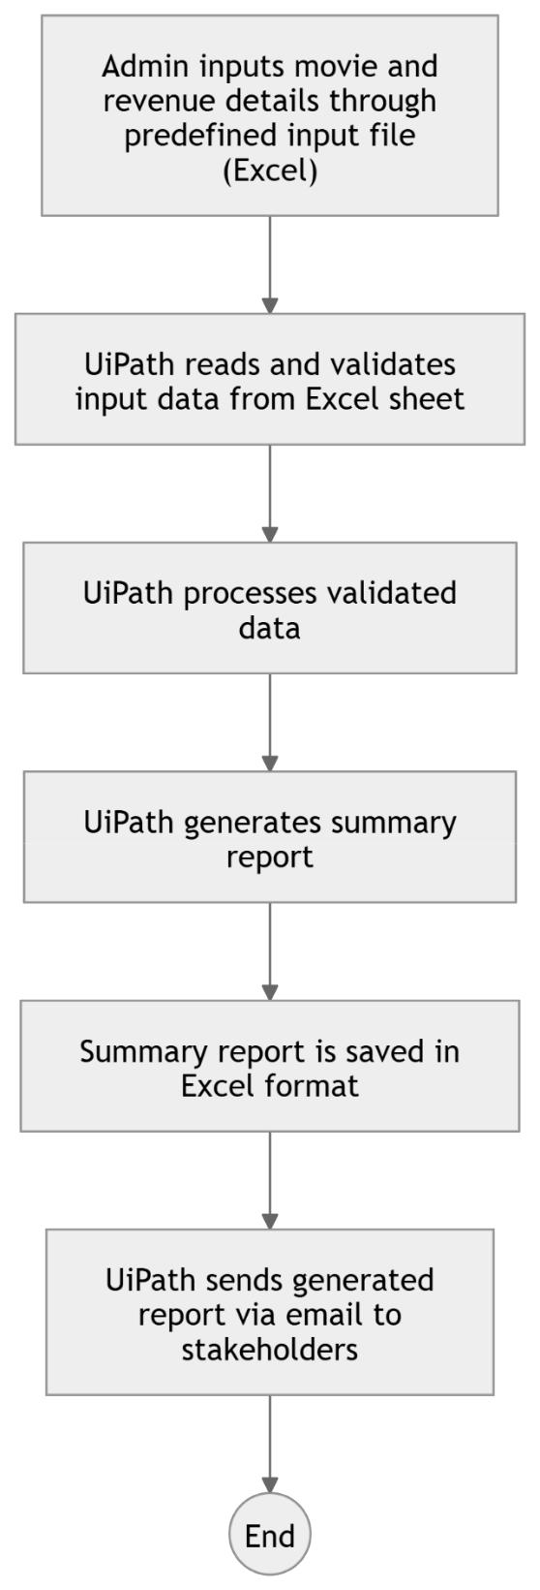

Fig 3.1.1 System Flow Diagram

5

**3.1.2 Architecture Diagram**

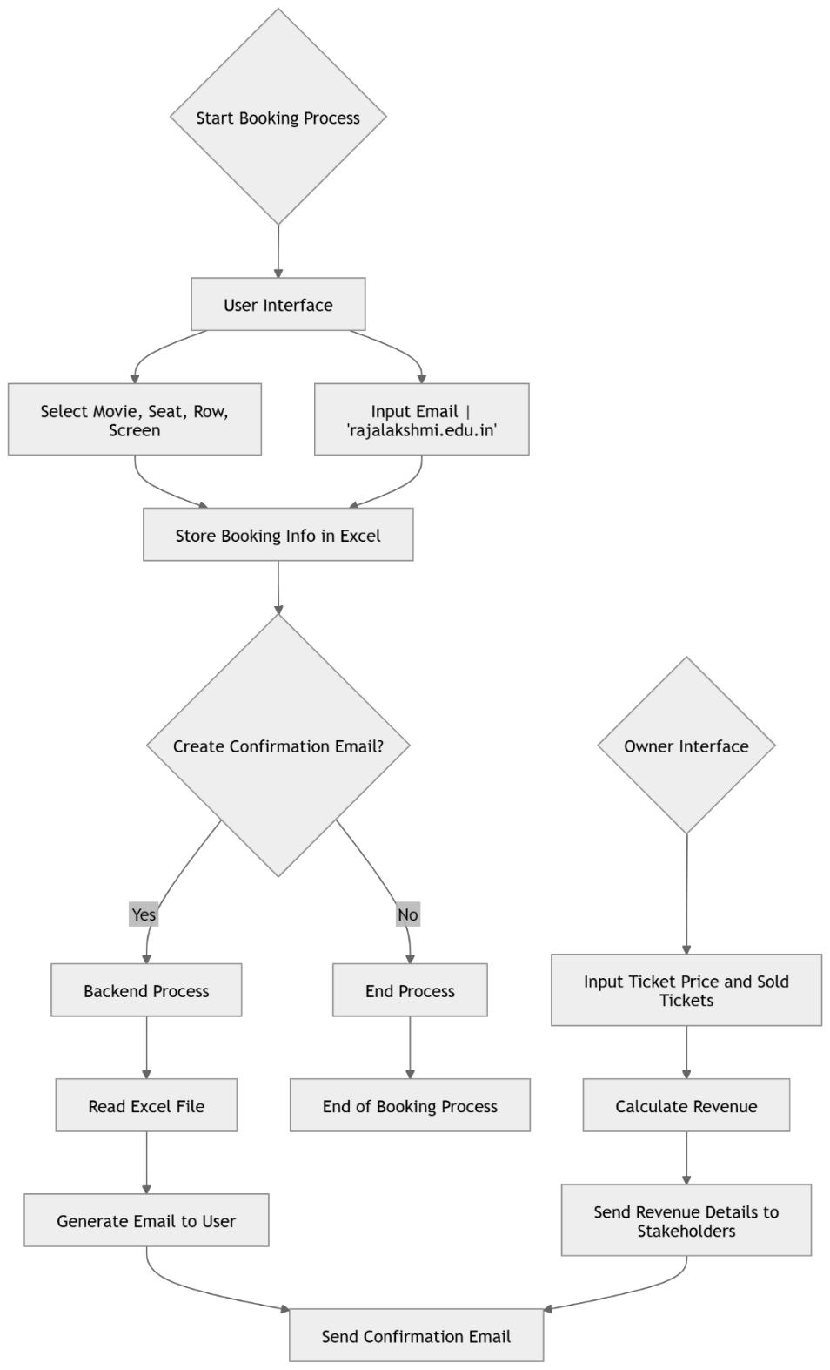

Fig 3.1.2 Architecture Diagram

6

**3.1.3 Sequence Diagram**

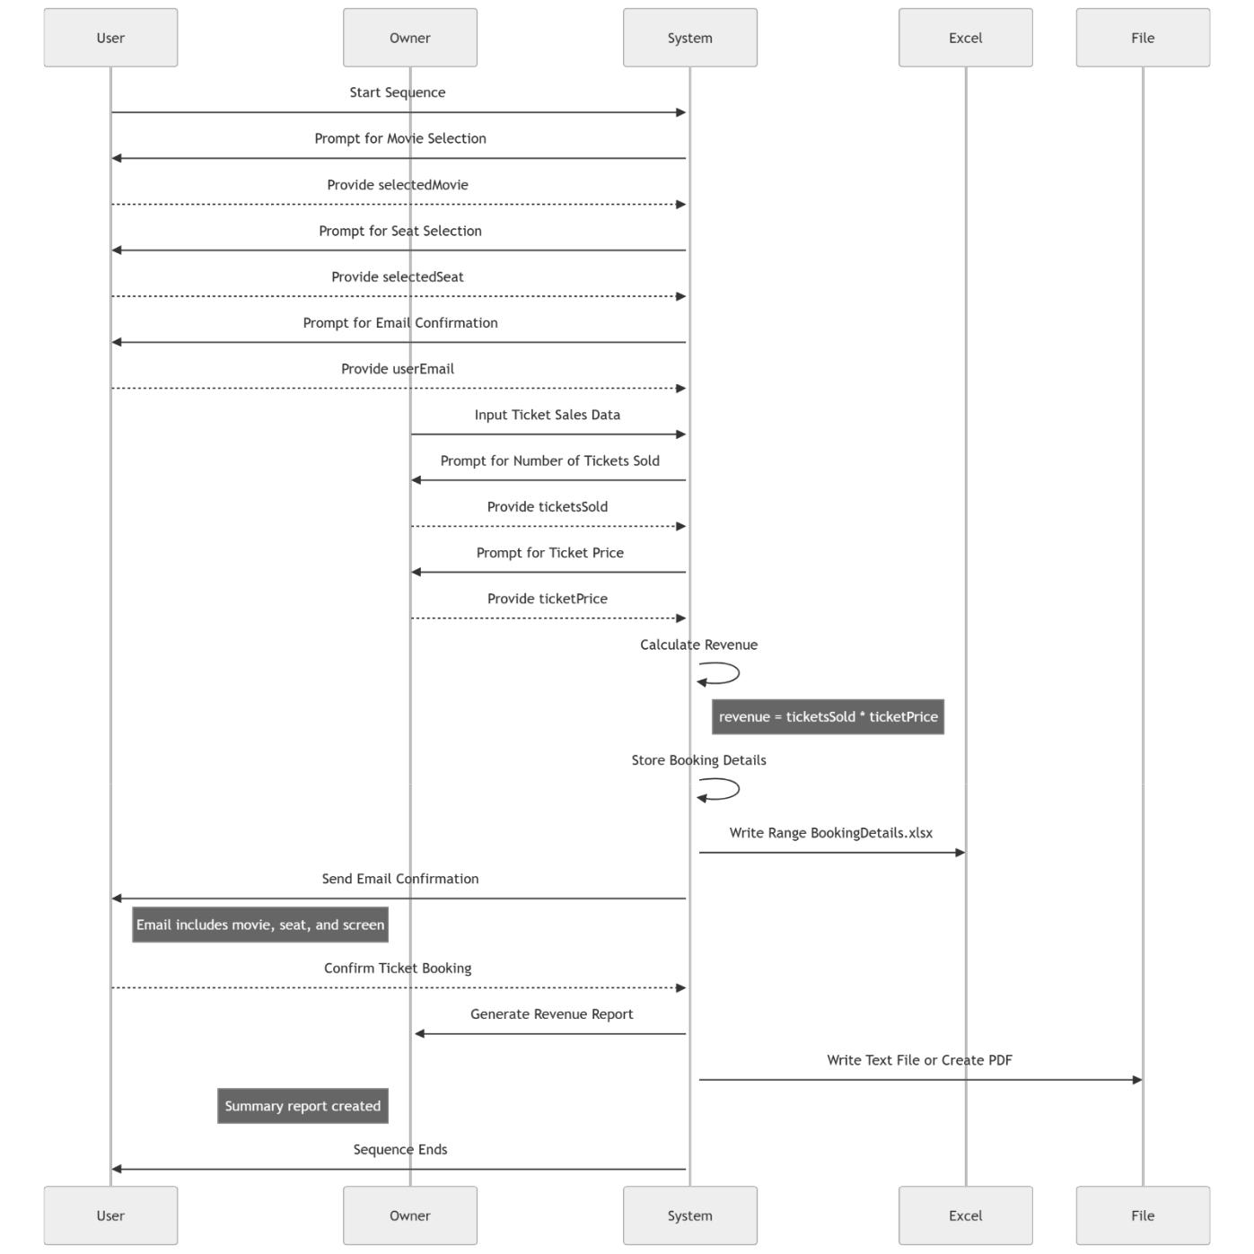

Fig 3.1.3 Sequence Diagram

7

**CHAPTER 4**

**PROJECT DESCRIPTION**

**4.1 Methodologie**

This project automates the process of capturing student data, storing it in an Excel file, and sending the data report to the user via email. Using UiPath Studio, the data is collected from user input, stored in an Excel sheet, and then used to generate and email a report. The process ensures accurate and efficient data collection, storage, and reporting without manual intervention.

**Methodology:**

1. **User Input Collection:**
2. The automation begins by collecting student data through **UiPath Input Dialog** or **Forms** activities. Users enter details like name, age, course, email, etc.
   1. The inputs are validated to ensure that the data is in the correct format before proceeding.
3. **Data Storage in Excel:**

o

o

After the user submits the data, the information is stored in an **Excel file** using the **Write Range** or **Append Range** activity in UiPath.

Each new entry is added to a new row, ensuring data is organized and accessible.

1. **Report Generation:**
2. Once the data is entered into the Excel file, the automation creates a report summarizing the entered information. This can be done by reading the data from the Excel file and formatting it into a structured report.
   1. The report is saved as an Excel or PDF file for easy sharing.
3. **Email Automation:**
4. The generated report is **Send Outlook Mail** or

automatically sent to the user or specified recipient via **SMTP Mail** activity in UiPath.

8

* 1. The email includes the report file as an attachment, ensuring the recipient receives the necessary data in a timely manner.

1. **Error Handling:**
   1. Throughout the automation process, **Try-Catch** blocks are used to handle any

potential errors, such as invalid input or issues in sending the email.

* 1. **Log Message** activities are used to track successful data entries or failures for troubleshooting.

1. **Reporting and Logging:**
   1. The automation creates logs of each operation, recording success and failure

events using **Write Line** or **Log Message** activities.

* 1. A summary report is generated to confirm the successful execution of the process, including details of the student data entries and emails sent.

1. **Testing and Optimization:**
   1. The automation process is tested using sample data to ensure the input, storage, report generation, and email sending steps work smoothly.
   2. Optimizations are made to the process by ensuring minimal delays and checking that the input fields, Excel storage, and email actions are efficient.
2. **Deployment:**
   1. Once the workflow is tested and optimized, it is ready for deployment.
3. The automation can be scheduled or run on demand to handle student data entries and email reports at regular intervals or when triggered.

9

**4.1.1 Modules**

The project is divided into the following modules:

**1.Movie Selection (User Input)**

•

•

**Objective**: Allow users to select a movie for booking tickets.

**Activities**:

1. Use UiPath's **Input Dialog** or **Form Activities** to prompt the user to choose a movie from a list.
   * 1. Store the movie selected by the user in a variable for further processing.
2. **Seat Selection (User Input)**
   * **Objective**: Enable users to choose the number of seats they want to book.
   * **Activities**:
     1. Use **Input Dialog** to ask for the number of tickets/seats.
     2. Validate the input to ensure it's a valid number and seats are available.
3. **Ticket Confirmation (User Confirmation)**
   * **Objective**: Confirm user selections before booking tickets.
   * **Activities**:
     1. Show a summary of the movie, seats, and total cost to the user using **Message Box** or **Text Box**.
     2. Ask for confirmation using **Yes/No** options. If confirmed, proceed to the next step.
4. **Ticket Price Calculation (Owner Input)**
   * **Objective**: Allow the owner to input ticket price and track revenue.
   * **Activities**:

10

1. Use **Input Dialog** to allow the owner to enter the ticket price for the selected movie.
   * 1. Calculate the total revenue by multiplying the ticket price by the number of tickets sold.
2. **Booking Confirmation and Record Keeping**
   * **Objective**: Confirm the booking and store ticket booking details.
   * **Activities**:
     1. Generate a ticket ID for the booking.
3. Use **Write Range** to store the booking details in an Excel sheet or a CSV file (e.g., movie name, seats booked, price, and total revenue).
   * 1. Send an email to the user with their booking details (movie name, seats, ticket price, and ticket ID).
4. **Revenue Tracking (Owner View)**
   * **Objective**: Allow the owner to track total revenue generated from ticket sales.
   * **Activities**:
     1. Use UiPath's **Excel Read Range** to fetch the stored data of ticket sales and revenue.
     2. Summarize and calculate the total revenue for the day, week, or month.
5. **Email Notification (User Confirmation)**
   * **Objective**: Send a booking confirmation email to the user.
   * **Activities**:
     1. Use **Send Outlook Mail Message** or **SMTP** to send a detailed email to the user with the ticket booking details (movie name, number of tickets, seat numbers, total price, ticket ID).
6. Optionally, include a QR code or a PDF attachment of the ticket for the user.

11

1. **Reporting & Summary Generation (Owner Report)**
   * **Objective**: Generate a report for the owner to summarize total sales and revenue.
   * **Activities**:
2. Use **Excel Write Range** or **Write CSV** to create a report summarizing ticket sales and revenue.
   * 1. Optionally, send the summary report to the owner via email at regular intervals (e.g., daily or weekly).
3. **Data Validation and Error Handling**
   * **Objective**: Handle errors and invalid inputs gracefully.
   * **Activities**:
     1. Use **Try Catch** to manage errors like invalid input or failed email sending.
     2. Log any issues using **Log Message** and provide feedback to the user or owner.
4. **Scheduling and Deployment (Automation for Continuous Use)**
   * **Objective**: Automate ticket booking processes for continuous availability.
   * **Activities**:
     1. Deploy the process via **UiPath Orchestrator** to schedule ticket booking processes at regular intervals.
5. Monitor the process and ensure smooth operation without manual intervention.

12

**CHAPTER 5**

**CONCLUSIONS**

**5.1 GENERAL**

The **CineConnect: Streamlined Movie Registration and Revenue Tracker** project successfully utilizes Robotic Process Automation (RPA) to automate and optimize critical processes in the entertainment industry. By integrating UiPath's powerful RPA capabilities, the project addresses the inefficiencies associated with manual movie registration, ticket sales tracking, and revenue reporting, thereby streamlining operations and ensuring real-time accuracy.

Key findings from the development and implementation of the **CineConnect** project include:

1. **Automation Benefits:**
   * The system automates movie selection, seat booking, revenue tracking, and email notifications, eliminating the need for manual intervention.
   * This reduces human errors, enhances accuracy, and ensures faster processing of large volumes of ticket booking data.
   * The automated process ensures timely booking confirmations and generates real-time revenue reports, providing stakeholders with immediate, actionable insights.
2. **Scalability:**
   * The system can easily handle various movie and seat bookings, as well as large-scale data collection and reporting, without compromising performance.
   * Through UiPath Orchestrator, the system can be deployed, scheduled, and monitored for batch processing, making it scalable across multiple theaters or cinema chains.
3. **Flexibility and Customization:**
   * CineConnect offers flexibility in adapting to different cinema or theater requirements. For instance, the system can integrate with varying movie schedules, pricing models, and seat configurations.

13

* + The solution is highly customizable, allowing for adjustments in the booking flow, revenue calculations, and reporting formats without requiring significant rework.

1. **Error Handling and Monitoring:**
   * The system includes robust error-handling mechanisms, which automatically address issues such as incorrect data inputs or failed booking transactions.
   * Real-time monitoring and error logging ensure that problems are quickly detected and resolved, ensuring minimal disruption in operations.
2. **Integration with UiPath Orchestrator:**
   * Deploying the solution via UiPath Orchestrator allows CineConnect to run autonomously without constant supervision.
   * Scheduled tasks ensure continuous operation, while real-time monitoring features of Orchestrator provide performance tracking, detailed logs, and alerts for any operational anomalies.
3. **Improved Operational Efficiency:**
   * CineConnect significantly reduces manual workload, saving time for staff and allowing them to focus on strategic decision-making and customer engagement.
   * By automating the revenue tracking and ticketing processes, CineConnect ensures that the system runs efficiently, accurately, and without delays.
4. **Enhanced Decision-Making:**
   * The automated reporting features allow theater owners to generate real-time revenue reports, which support better decision-making.
   * By providing accurate data insights, the system helps identify trends, peak ticket sales periods, and customer preferences, enabling businesses to make informed strategic decisions.

14

**Conclusion:**

The **CineConnect: Streamlined Movie Registration and Revenue Tracker** project highlights the transformative power of RPA in automating routine tasks and streamlining business operations within the entertainment sector. The integration of UiPath’s RPA capabilities not only enhances operational efficiency but also improves accuracy, reduces human errors, and provides valuable real-time insights.

With a scalable and adaptable architecture, the system offers a robust solution to the movie industry’s data and revenue tracking challenges. Future enhancements could include the integration of predictive analytics for revenue forecasting, incorporating AI-driven customer behavior insights, and expanding the system’s compatibility with different booking platforms and payment gateways.

In essence, CineConnect offers a future-proof solution for automating the movie ticket booking and revenue tracking process, optimizing both customer experience and business operations.

15

**REFERENCES**

1. UiPath Official Documentation. (n.d.). Robotic Process Automation (RPA) Overview. Retrieved from <https://www.uipath.com/>
2. Jain, S., & Bhutani, S. (2020). Robotic Process Automation (RPA): A Literature Review and Implementation in Business Processes. International Journal of Advanced Research in Computer Science and Software Engineering, 10(7), 42-47.
3. Huang, K. T., & Lee, R. W. (2021). Automation of Contract Management Systems Using Robotic Process Automation (RPA). Journal of Business & Technology, 23(3), 134-140. <https://doi.org/10.5555/jbt.2021.23.3.134>
4. Brown, G. (2020). The Future of Automation in Business Processes: A Focus on RPA Tools. Springer International Publishing.
5. Bhatnagar, A. (2021). Optimizing Business Workflows with UiPath RPA: A Comprehensive Guide. Wiley Publishing
6. Zhu, Y., & Ouyang, L. (2019). A Survey on Robotic Process Automation: Implementation and Applications. International Journal of Computer Applications, 182(5), 1-6. <https://doi.org/10.5120/ijca201991847>

These references provide foundational knowledge on RPA, particularly focusing on automation tools like UiPath, contract management automation, and RPA's impact on business processes.

16

**SCREENSHOTS**

1. Workflow Screenshot

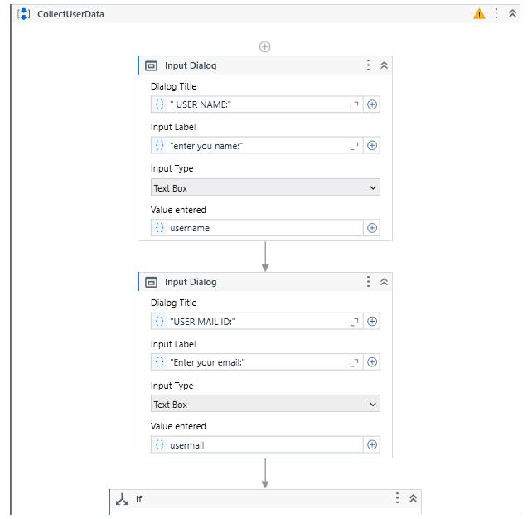

Screenshot 1

17

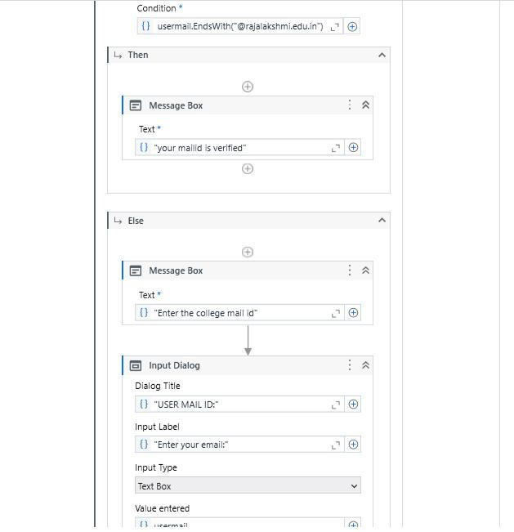

Screenshot 2

18

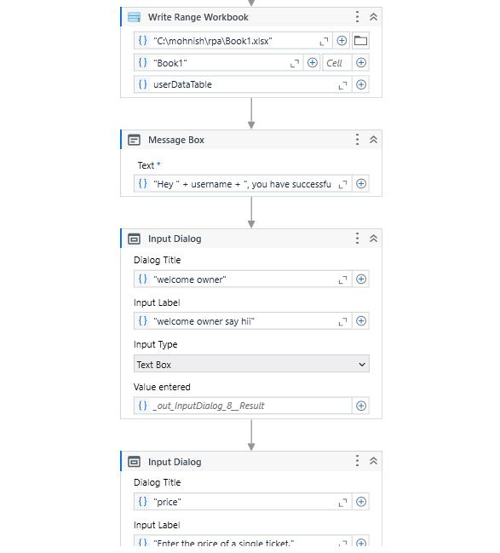

Screen shot 3

19

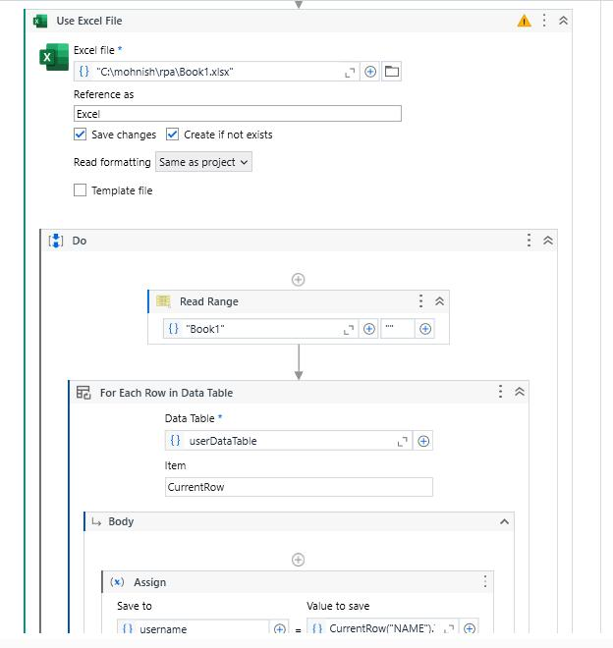

Screen shot 4

20

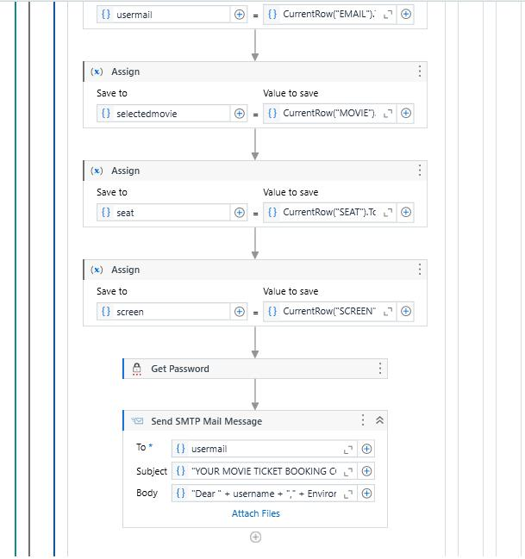

Screen shot 5

21

**APPENDICES**

**Appendix 1: Sample Excel Sheet (Student Data)**

|  |  |  |  |  |
| --- | --- | --- | --- | --- |
| NAME | EMAIL | MOVIE | SEAT | SCREEN |
|  |  |  |  |  |
| Madhan raj | 220701148@rajalakshmi.edu.in | coolie | row C | Screen 1 |
|  |  |  |  |  |

**Appendix 2: UiPath Activities Used**

1. **Excel Application Scope** - Used to interact with the Excel file containing movie booking data.

o **Input**: File path of the Excel sheet (MovieBookingData.xlsx).

o **Output**: Access to the Excel data table.

1. **Read Range** - Reads the entire data from the Excel sheet and outputs it as a DataTable.

o **Input**: Excel sheet name (e.g., "Sheet1").

o **Output**: DataTable variable (e.g., dtBookingData).

1. **For Each Row** - Loops through each row in the DataTable.
2. **Input**: dtBookingData
   1. **Output**: Each row processed in the loop.
3. **Assign** - Used to extract and store data from the source file for further processing.
   1. **Input**: Columns from the Excel file representing customer details (e.g., Name,
   2. **Output**: Variables populated with respective booking data (e.g., CustomerName, CustomerEmail, Movie, Seat, Screen).
4. **If** - Conditional logic used to verify data completeness before processing.
   1. **Input**: Conditions such as Not String.IsNullOrEmpty(row("Name").ToString())

to check if required fields are populated.

* 1. **Output**: Ensures only complete and valid data is processed for ticket booking.

1. **Send Outlook Mail** - Sends email confirmation to the customer with their booking details.

22

1. **Input**: Email configuration with recipient email, subject (e.g., "Ticket Booking Confirmation"), and body (e.g., details of the movie, seat, and screen).
   1. **Output**: Email sent to the user confirming their booking.
2. **Click** - Automates the button click for submitting the booking form.
   1. **Input**: Selector for the "Submit" button in the booking form.
   2. **Output**: Submission of booking details.
3. **Write Cell** - Updates the source Excel file to indicate the status of the booking.
   1. **Input**: Column in the Excel file (e.g., "Booking Status") and a value like "Confirmed" or "Pending."
4. **Output**: Excel file updated to track which bookings have been processed.

**Appendix 3: Screenshots of UiPath Studio Activities**

1. **Workflow Overview**:

A screenshot showing the sequence of activities used in UiPath Studio, including: o **Excel Application Scope**: Accessing the movie booking data from Excel. o **Read Range**: Reading the entire data into a DataTable.

o **For Each Row**: Iterating through the movie booking data.

o **If conditions**: Validating data completeness (e.g., checking if name, movie, and seat are provided).

o **Send Outlook Mail**: Sending an email confirmation to the customer.

o **Write Cell**: Updating the Excel file with the booking status.

1. **Send Email Configuration**:

A screenshot showing the configuration of the **Send Outlook Mail Message** activity with:

o Recipient email address (e.g., user’s email).

o Subject line (e.g., "Your Movie Ticket Booking Confirmation").

o Email body containing the movie details, seat, and screen confirmation.

1. **Excel Data Update**:

A screenshot showing the updated Excel sheet where the **"Booking Status"** column is updated after ticket bookings are processed, with entries like "Confirmed" or

"Pending."

23